Report
Of
SALES FORECASTING USING TIME-SERIES ANALYSIS

Submitted
To

School of Computer Science and Engineering
IILM University, Greater Noida, U.P.

In partial fulfilment of the requirement of degree of
MCA



By

Roll Number of Student: 25SCS2040003928
Name of Student: SARIKA KUMARI
Batch: 2025-2027

2026-27

TABLE OF CONTENTS

Chapter No. | Chapter Name | Page Nos.
 | Cover Page | ----
 | Table of Contents | i
1. | Candidate's Declaration | ii
2. | Acknowledgment | iii
3. | Internship Completion Certificate | iv
4. | Project Description  4.1 Introduction  4.2 Organization Profile  4.3 Problem Statement  4.4 Project Objectives  4.5 Scope of the Project  4.6 Technologies and Tools Used  4.7 System Architecture  4.8 Methodology  4.9 Expected Outcomes  4.10 Certificates of Completion & Communication Proof | 1
5. | Bibliography / References | 5

CANDIDATE'S DECLARATION

I, Sarika Kumari, do hereby declare that the internship report titled “Sales Forecasting Using Time-Series Analysis” has been completed by me to fulfil the requirement for the award of the degree of Master of Computer Applications (MCA). All the references have been quoted and I have not taken as such any material from any other source. I affirm that this report is my own work and has not been submitted to any other institute for any degree/diploma requirement, and further I shall be solely responsible for any kind of copyright violation in this regard.

Signature
Student Name: Sarika Kumari
Roll No.: 25SCS2040003928

ACKNOWLEDGEMENT

I am using this opportunity to express my gratitude to everyone at Codec Technologies Pvt. Ltd. who supported me throughout the Internship Program. I am thankful for their aspiring guidance, invaluably constructive criticism, and friendly advice extended to me during the course of this internship. I would like to sincerely thank Dr. Anurag Shrivastava and the entire project team for their mentorship, and for sharing their truthful and illuminating views on a number of issues related to Data Analytics and this project.
I would also like to thank the School of Computer Science and Engineering, IILM University, Greater Noida, for providing me the opportunity to undertake this AICTE-approved internship as part of my academic curriculum.
I express my gratitude to my parents for their blessings and constant support.

Signature
Student Name: Sarika Kumari
Roll No.: 25SCS2040003928

INTERNSHIP OFFER LETTER

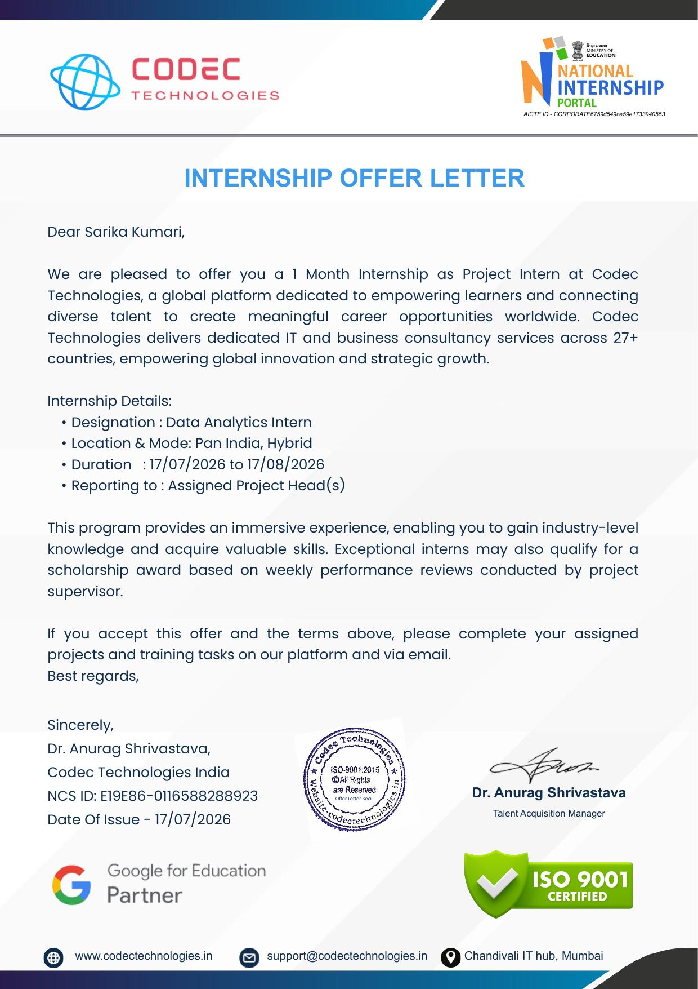

INTERNSHIP COMPLETION CERTIFICATE

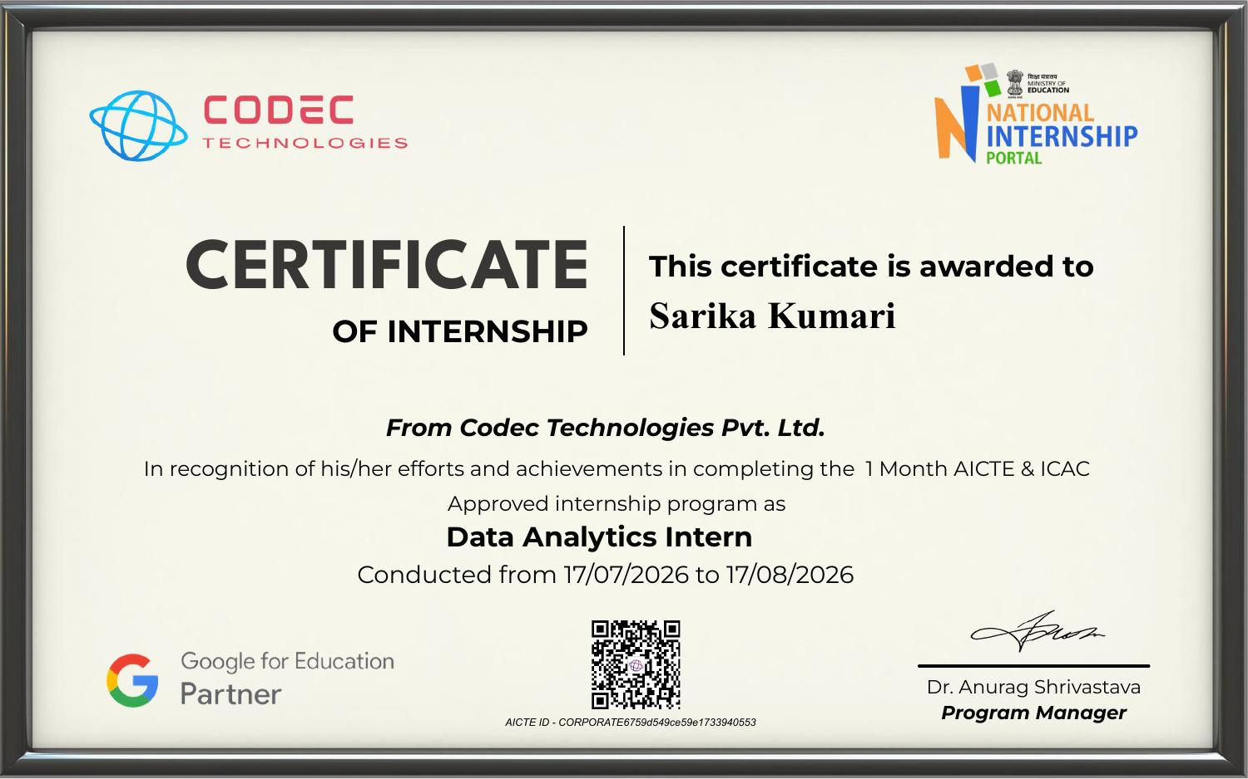

CHAPTER 4
PROJECT DESCRIPTION

4.1 Introduction
As part of the AICTE and ICAC approved internship program, I underwent a one-month internship as a Data Analytics Intern at Codec Technologies Pvt. Ltd. from 17/07/2026 to 17/08/2026. The internship was designed to provide industry-level exposure to real-world data analytics workflows, and the project assigned to me was titled “Sales Forecasting.”
The project focuses on predicting future sales of a retail/e-commerce business using historical time-series data. Accurate sales forecasting is a critical requirement for businesses as it directly influences inventory planning, staffing, marketing budgets, and overall strategic decision-making. This report documents the problem statement, objectives, methodology, tools used, and expected outcomes of the project undertaken during the internship.
4.2 Organization Profile
Codec Technologies Pvt. Ltd. is a global platform dedicated to empowering learners and connecting diverse talent to create meaningful career opportunities worldwide. The organization delivers dedicated IT and business consultancy services across 27+ countries, empowering global innovation and strategic growth. Codec Technologies is an ISO 9001:2015 certified organization and a Google for Education partner, and it conducts its internship programs through the National Internship Portal under AICTE and ICAC approval.
The internship program is structured to provide an immersive learning experience, enabling interns to gain industry-level knowledge and acquire valuable technical skills. Exceptional interns are also considered for a scholarship award based on weekly performance reviews conducted by the project supervisor.
4.3 Problem Statement
Retail and e-commerce businesses generate large volumes of historical sales data every day, but this data is often underutilized for planning purposes. Without a reliable forecasting mechanism, businesses struggle to anticipate demand fluctuations caused by seasonality, promotional campaigns, and long-term trends. This leads to problems such as overstocking, stock-outs, inefficient budget allocation, and missed revenue opportunities.
The core problem addressed in this project is: given historical sales data, how can we build a reliable time-series forecasting model that predicts future sales while accounting for seasonal patterns, promotional effects, and underlying trends?
4.4 Project Objectives
- To collect and pre-process historical retail/e-commerce sales data suitable for time-series forecasting.
- To perform exploratory data analysis (EDA) and identify trend, seasonal, and promotional components in the data.
- To build and compare forecasting models using ARIMA, Prophet, and LSTM approaches.
- To evaluate model performance using standard error metrics (MAE, RMSE, MAPE).
- To visualize the forecasted sales against actual sales for clear interpretability.
- To derive actionable business insights from the forecasting results.
4.5 Scope of the Project
The scope of this project is limited to univariate and multivariate time-series forecasting of sales data using publicly available or simulated retail/e-commerce datasets. The project covers data cleaning, decomposition of trend/seasonality/promotional effects, model building using ARIMA, Prophet, and LSTM, and visualization of forecast results. It does not extend to live deployment of the model into a production environment, real-time data pipelines, or integration with a company's live ERP/POS systems, as the primary objective within the internship duration was to demonstrate a working forecasting methodology and its evaluation.
4.6 Technologies and Tools Used
- Programming Language: Python
- Data Handling: Pandas, NumPy
- Statistical Modelling: statsmodels (ARIMA/SARIMA)
- Forecasting Library: Facebook Prophet
- Deep Learning: TensorFlow / Keras (LSTM)
- Visualization: Matplotlib, Seaborn, Plotly
- Development Environment: Jupyter Notebook / Google Colab
- Version Control: Git and GitHub
4.7 System Architecture
The system architecture followed for this project is a standard time-series forecasting pipeline, moving from raw data ingestion to final visualization, as summarized below:
1. Data Collection – Gathering historical sales data (date, units sold, revenue, promotions, etc.)
2. Data Pre-processing – Handling missing values, formatting dates, and resampling the series
3. Exploratory Data Analysis – Visualizing trend, seasonality, and promotional spikes
4. Feature/Seasonal Decomposition – Separating trend, seasonal, and residual components
5. Model Building – Training ARIMA, Prophet, and LSTM models on the training set
6. Model Evaluation – Comparing models using MAE, RMSE, and MAPE on the test set
7. Visualization – Plotting forecasted sales against actual sales
8. Insights & Reporting – Summarizing findings for business decision-making

4.8 Methodology
The project was carried out using the following step-by-step methodology:
- Data Collection: Historical time-series sales data was sourced from an open retail/e-commerce dataset, containing daily/weekly/monthly sales figures along with promotional flags.
- Data Cleaning: Missing values were imputed, duplicate records were removed, and the date column was converted into a proper datetime index.
- Stationarity Check: The Augmented Dickey-Fuller (ADF) test was used to check stationarity of the series; differencing was applied where required.
- Seasonal Decomposition: The series was decomposed into trend, seasonal, and residual components to understand underlying patterns.
- Train-Test Split: The data was split chronologically into training and testing sets to preserve the time-series order.
- ARIMA Modelling: ACF and PACF plots were used to identify the (p, d, q) parameters, and an ARIMA/SARIMA model was fitted to capture trend and seasonality.
- Prophet Modelling: Facebook Prophet was used to model trend, yearly/weekly seasonality, and promotional events as additional regressors.
- LSTM Modelling: A Long Short-Term Memory neural network was built using sequences of past sales values to capture non-linear temporal dependencies.
- Model Evaluation: All three models were compared on the test set using MAE, RMSE, and MAPE to identify the best-performing approach.
- Visualization: Forecasted values from each model were plotted against actual sales to visually assess accuracy and interpretability.
4.9 Expected Outcomes
- A working sales forecasting pipeline capable of predicting future sales from historical data.
- A comparative understanding of ARIMA, Prophet, and LSTM models for time-series forecasting.
- Clear visualizations showing forecasted sales versus actual sales, including seasonal and promotional effects.
- Quantified model performance using MAE, RMSE, and MAPE metrics.
- Actionable insights that can support inventory planning, marketing scheduling, and revenue forecasting for the business.
4.10 Certificates of Completion and Communication Proof
The following documents are attached as proof of internship completion and communication with the organization: the Internship Offer Letter and the Internship Completion Certificate issued by Codec Technologies Pvt. Ltd.

CHAPTER 5
BIBLIOGRAPHY / REFERENCES

1. Hyndman, R.J. and Athanasopoulos, G., "Forecasting: Principles and Practice," OTexts, 3rd Edition.
2. statsmodels documentation – Time Series Analysis (ARIMA/SARIMAX), https://www.statsmodels.org
3. Facebook Prophet documentation, https://facebook.github.io/prophet/
4. TensorFlow/Keras documentation – Recurrent Neural Networks (LSTM), https://www.tensorflow.org
5. Codec Technologies Pvt. Ltd., Internship Offer Letter and Internship Completion Certificate, 2026.
6. Pandas documentation, https://pandas.pydata.org

